ACADEMIC PLAN – Fall 2024 – Honors Psychology

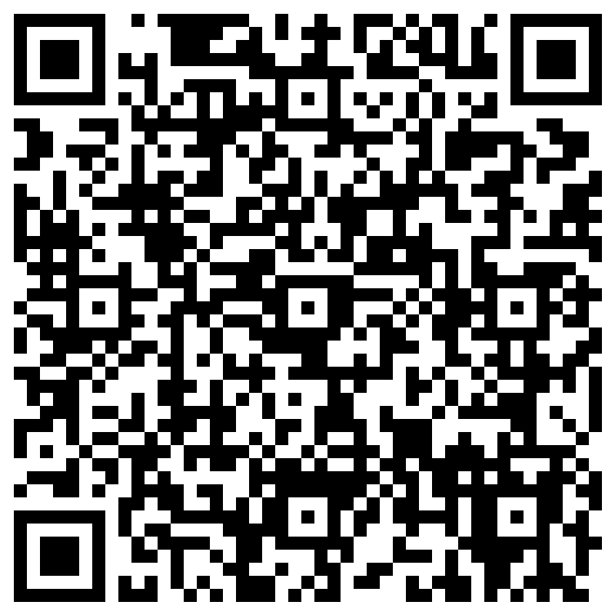
Teacher: C. Repko
Room: 108
Email: repkoc@gcsnc.com
Phone: 336.674.4250 ext. 604

Course Objectives: The study of Psychology is the Social Science of the human mind and its interaction with its environment. Since its modern development in the 19th century, psychology has developed into an analytical and predictive science with numerous sub fields. As with any science, especially the social sciences, there are limitations to the scope of the field, yet psychology has made significant advances by focusing on its core goals: description, explanation, prediction and changing behavior.
Scan here to provide Parent Information.

Text: Psychology: Understanding Psychology (Glencoe); Digital Textbook will be available on Canvas

Grading (Final Exam counts as 20% of the final grade):

- Tests, Major Assignments – 50%

- Homework, Quizzes, Classwork - 50 %

Tests: Tests will be given, in-person, at the end of each unit. In longer units, a test may be given midway through the unit.

Homework, Quizzes, Classwork:
- All Homework assignments must be completed through the course Canvas page.
- Some Classwork will be completed in-person, some will be submitted through Canvas
- Homework will be assigned frequently.
- Quizzes may be announced or unannounced.

Absences: See information in the Student-Parent Handbook under the topics of “Choices” and “Student Attendance Policy.” All makeup time must be completed each quarter by the deadline I set (4 or more absences require makeup time in most cases). DO NOT wait until the last minute to makeup your time… Better yet, do not miss class.

Tardiness: Please do not be tardy to class. Frequent tardiness will result in discipline referrals per the SGHS Student Handbook

Supplies: Paper, Pen, Notebook

Class Rules:
- Be on task from “bell-to-bell.” You must be in your seat when the bell rings; do not “line-up” at the door before the end of class
- Follow directions the first time.
- Bring all necessary materials to class every day.
- Respect the rights of all at all times.
- Avoid disrupting instructional time for any reason (tardiness, poor behavior, sleeping, texting, excessive trips out of the room, etc.)
- No food or drink will be allowed in the classroom. This includes cafeteria food and drinks.

Cell Phone and Device Policy:
- Per GCS/Southern Guilford High School – Cell Phones, Ear buds etc., must be turned in at the beginning of class.
- School issued Chromebooks can be used for instructional purposes only. Use of Chromebooks for surfing the internet or other non-instructional purposes will result in inability to use the Chromebook during class time.
- Please charge your Chromebook each day prior to arriving in class. I do NOT have extra chargers for your use.

Consequences for inappropriate behavior:

1) Warning
2) Choices
3) Parent Contact
4) Discipline Form

Course Outline and Relevant Chapters (Dates are subject to change):

- 1st Quarter
  - Unit 1 – Introducing Psychology, Psychological Research Methods and Statistics. (Chapters 1,2) – Tentative Test Date 9/5
  - Unit 2 – Infancy and Childhood, Adolescence, Adulthood and Old Age. (Chapters 3,4,5) – Tentative Test Date 9/20
  - Unit 3 – Body and Behavior, Altered States of Consciousness, Sensation and Perception. (Chapters 6,7,8) – *This unit may be split in half. Tentative Test Dates 10/2 (3a),10/131(3b)
- 2nd Quarter
  - Unit 4 – Learning: Principles and Applications Memory and Thought, Thinking and Language, Motivation and Emotion. (Chapters 9,10,11,12) – Tentative Test Date TBA
  - Unit 5 – Psychological Testing, Theories of Personality. Chapters 13,14) – Tentative Test Date TBA
  - Unit 6 – Stress and Health, Psychological Disorders, Therapy and Change. (Chapters 15,16,17) – Tentative Test Date TBA
  - Unit 7 – Individual Interaction, Group Interaction. Attitudes and Social Influence, Psychology: Present and Future (Chapters 18,19,20,21) – Tentative Test Date TBA

